**Azure Load Balancer for RDP (Implement step by step)**

**Table of Contents**

1. Purpose of document
2. Understanding Load Balancer
3. “Load Balancer” use cases
4. Related Objects
5. Use case 1 (Implement Load Balancer for RDP port 3389)  
   5.1. Resource Group  
   5.2. Create Virtual Network (VNET)  
   5.3. Create Network Security Group (NSG)  
   5.4. Associate SN to NSG  
   5.5. Public IP address  
   5.6. Public Load Balancer  
   5.6.1. Backend Pool  
   5.6.2. Health Probes  
   5.6.3. Load balance rule  
   5.7. Virtual Machine  
   5.8. Load balancer Final Status  
   5.9. Connect Load balancer  
   5.10. Final result
6. End of Document

**Azure Load Balancer**

**1. Purpose of document**

Purpose of this document is to explain Azure Standard Load Balancer. Load Balancer is used for high availability of services. There are two types of Load balancer in Azure.

Standard load balancer can be used as a public or internal Load Balancer. **In this post Azure Public Load Balancer is explained.**

**2. Understanding Load Balancer**

Load balancer distribute load between Instances (VM’s, WebApps etc). Azure Load balancer can also redirect the request to other port. Load Balancers have several components (Frontend IP, Backend pools, Health probes, Load balance rules etc) explained in this demo.

**3. “Load Balancer” use cases**

**3.1 Use case 1: Jump Server RDP**

Most of the organization usually creates two Jump servers for managing IT infra, which contains lots of tools to manage entire infra.

* Like AD management consoles (Active Directory users and Computers, Active Directory sites and services, Group Policy Management etc.)
* PowerShell modules to connect Exchange, Skype etc
* Internet availability
* Linux system connectivity tools (Putty, WinSCP etc)

**Use Load Balancer between Jump Servers to distribute work load.**

**3.2 Use case 2: Web Server**

Most of the organization usually creates at least two or more Web servers to keep business up and running.

In this case should always keep all the Web servers in Load Balancer. See post <https://nsitautomation.in/azure-loadbalancer-for-web-server>

**4. Related Objects**

During the creation of the virtual machine in load balanced, additional properties will be reviewed, including the following:

* Public IP
* Dynamic vs Static IP Address
* Virtual Network
* Network Security Groups
* Virtual Machine
* Load Balancer
* Frontend pool
* Backend pool
* Host pool
* Load balancer rules

**5. Use case 1 (Implement Load Balancer for RDP port 3389)**

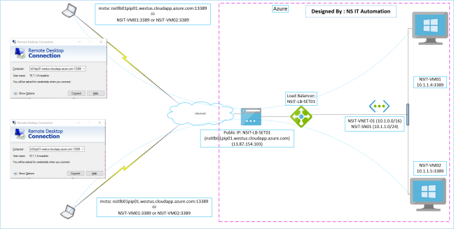

**5.1. Resource Group**

Login to Azure Portal [https://portal.azure.com](https://portal.azure.com/)

Create Resource Group: TEST-RG01

Region: West US

**5.2. Create Virtual Network (VNET)**

Create Virtual Network

VNET Name: NSIT-VNET-01

Address space: 10.1.0.0/16

Resource group: Select correct resource group

Location: West US

Subnet Name: NSIT-SN01

Subnet Address range: 10.1.1.0/24

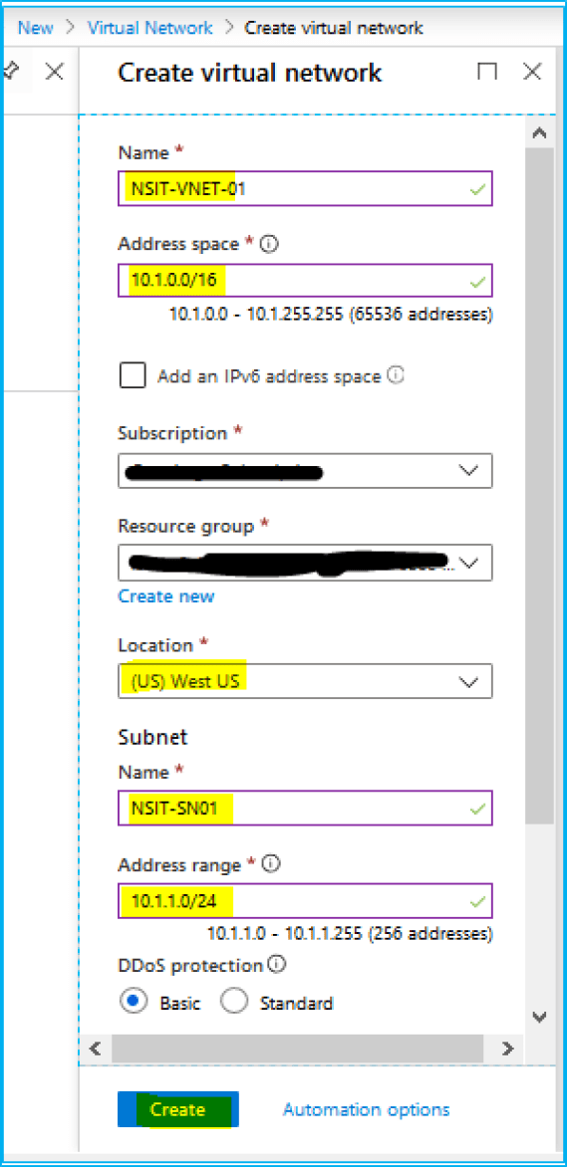

**5.3. Create Network Security Group (NSG)**

Create NSG’s

NSG Name: NSIT-NSG01

Resource group: Select correct resource group

Location: West US

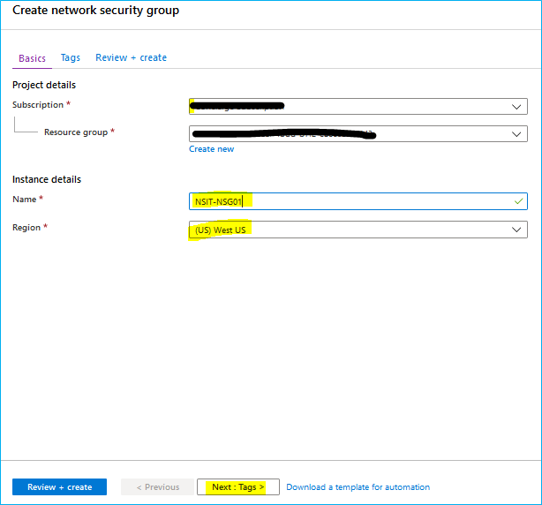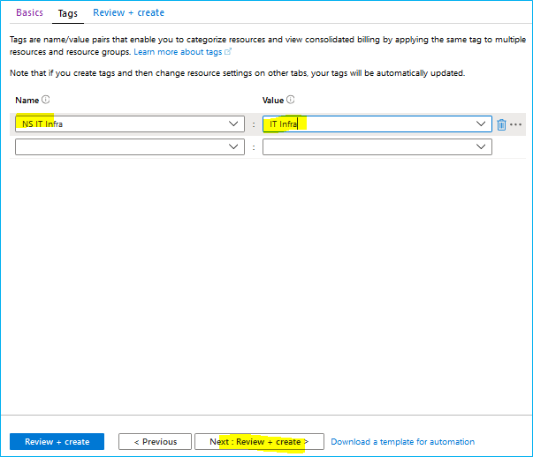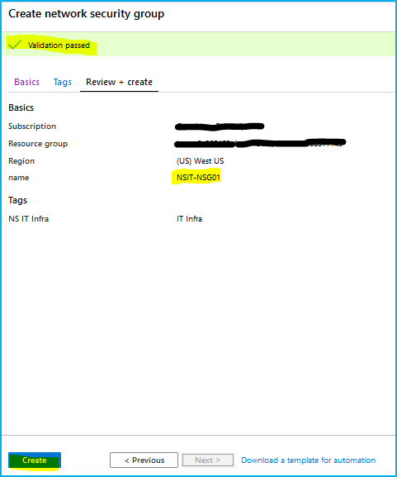

**5.4. Associate SN to NSG**

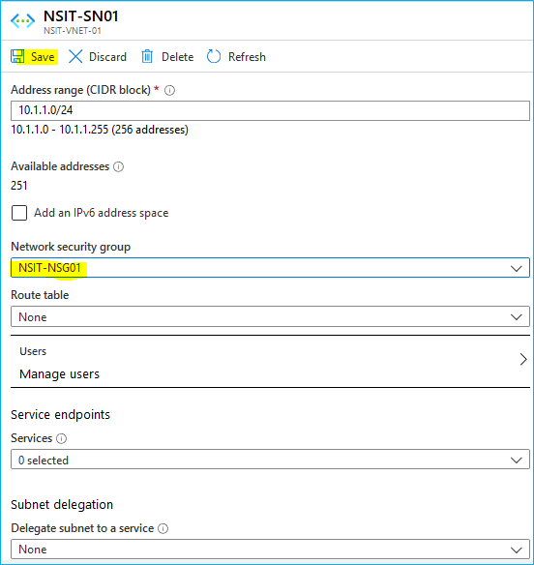

**5.5. Public IP address**

Create “Public IP address”

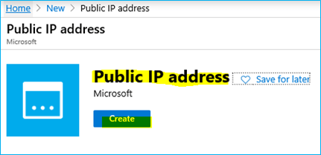

**Note:**

* Do not select Basic “SKU”. Select Standard SKU.
* SKU Standard is always static IP.
* Standard Azure Load Balancer support standard SKU.

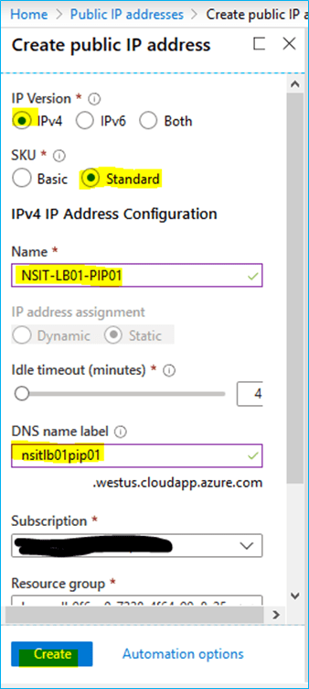

**5.6. Public Load Balancer**

Create “Load Balancer”

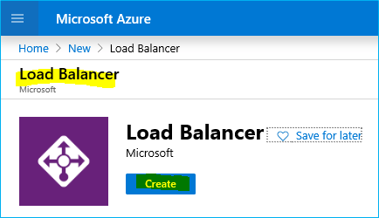

Do not create SKU: Basic

SKU: Standard

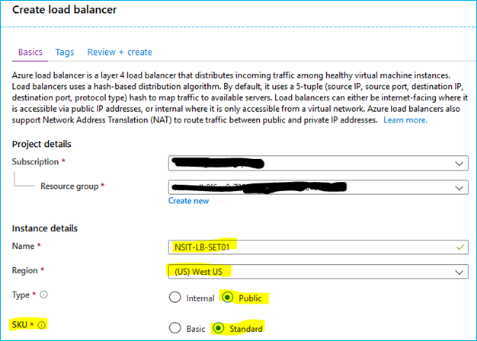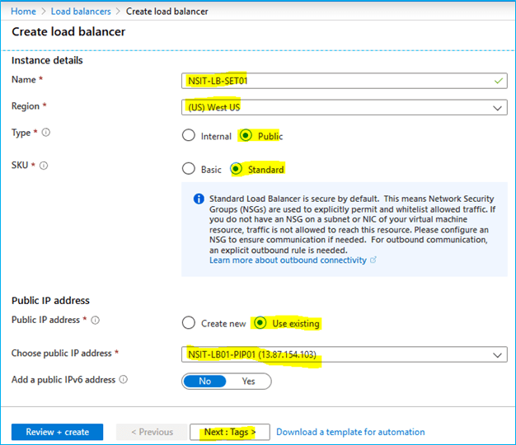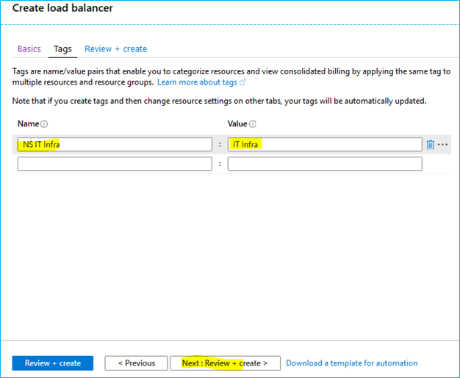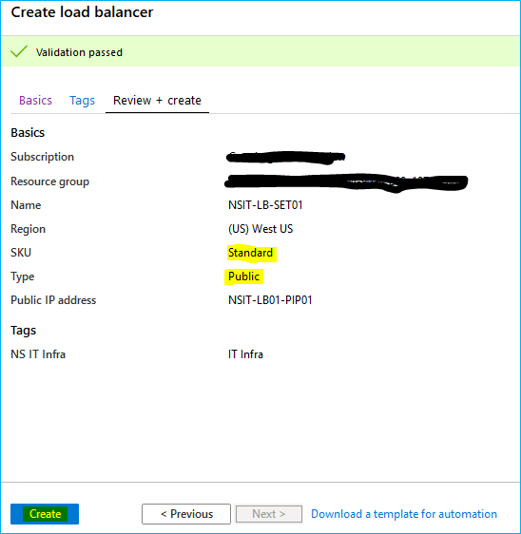

**5.6.1. Backend Pool**

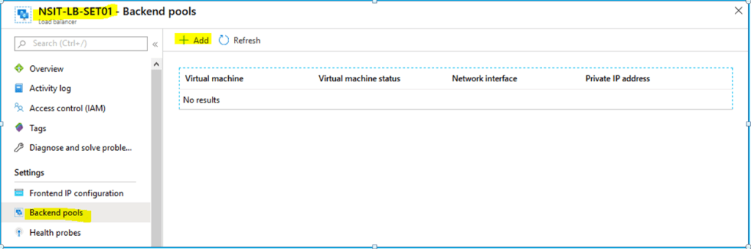

Add backend pool: NSIT-BE-POOL01

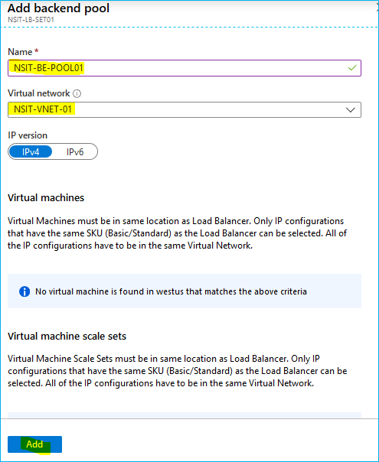

**5.6.2. Health Probes**

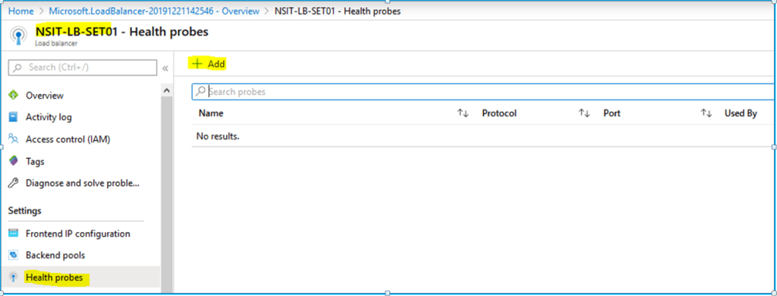

Add Health probes: NSIT-HP01

Health probes keep checking port availability of Backend servers. (Ex: RDP port 3389 health check)

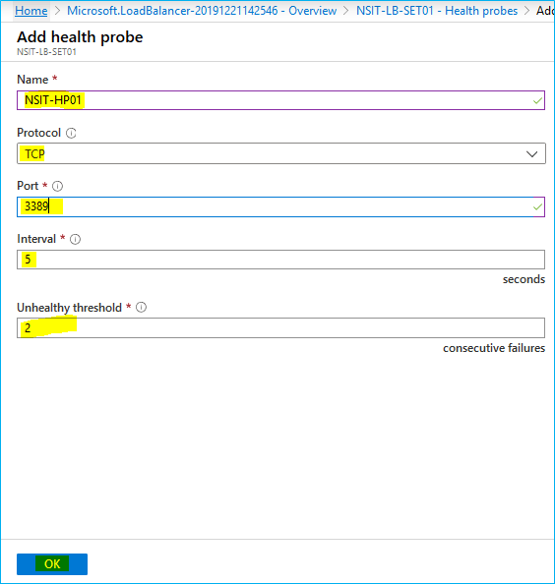

**5.6.3. Load balance rule**

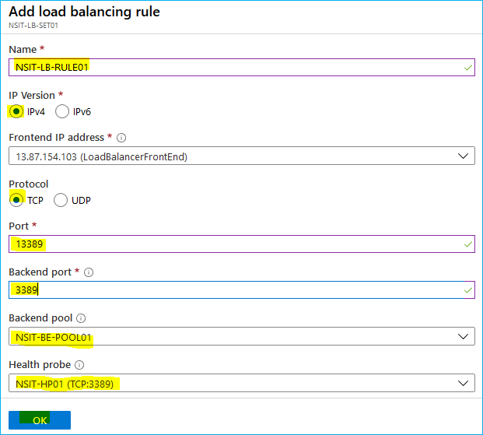

**5.7. Virtual Machine**

Create virtual machine and associate Load balancer and backend pool.

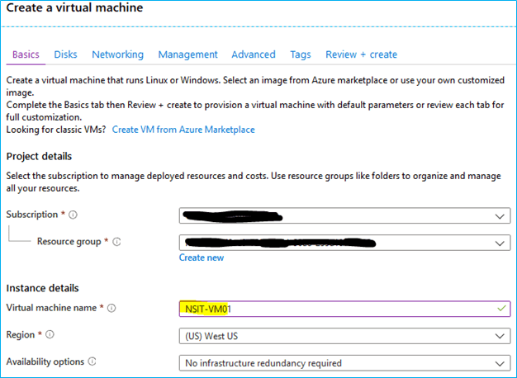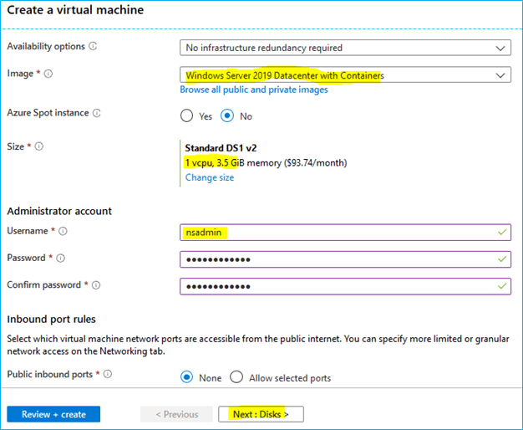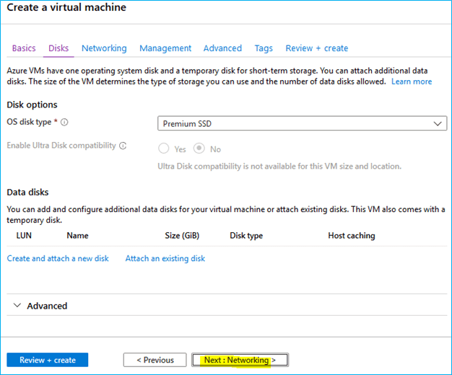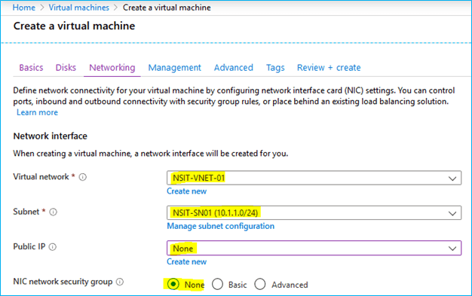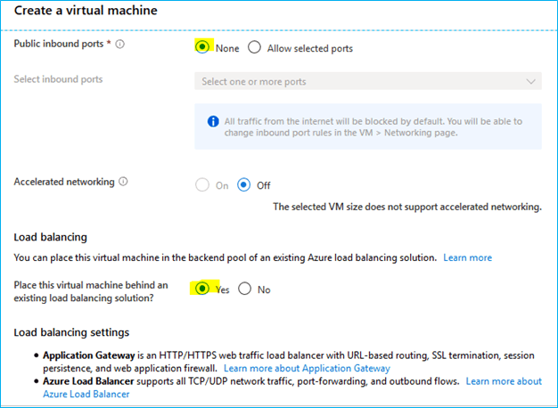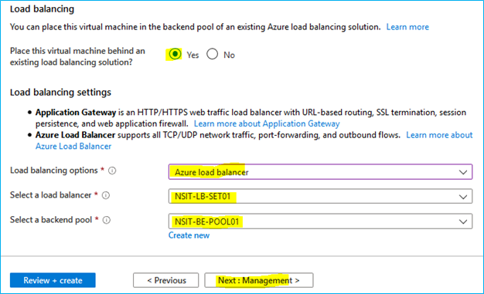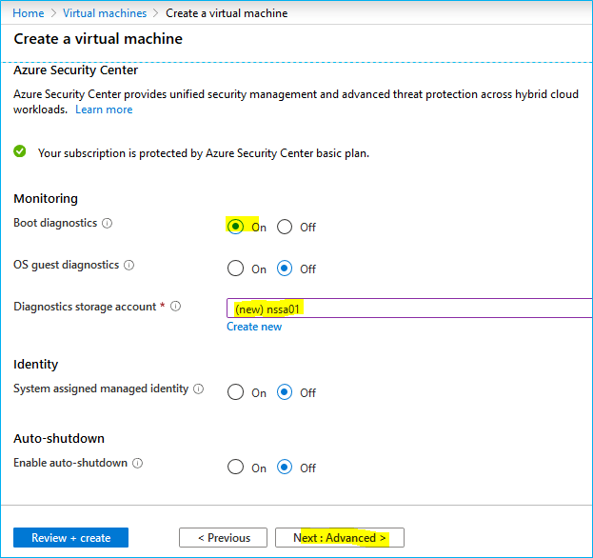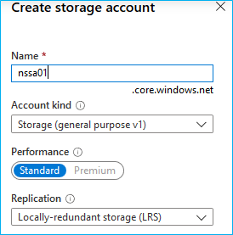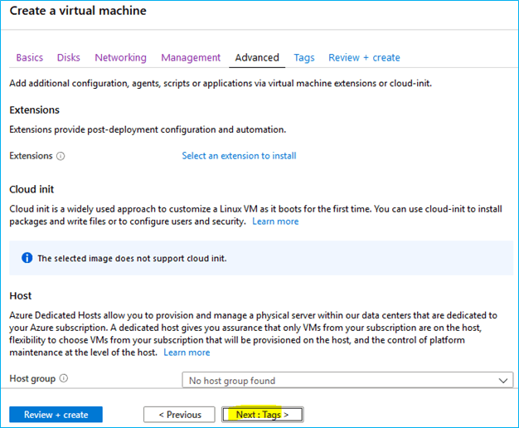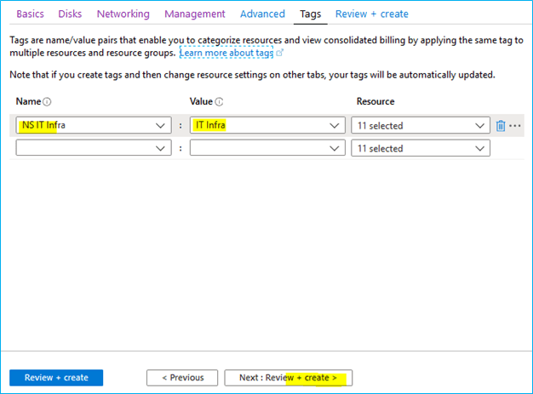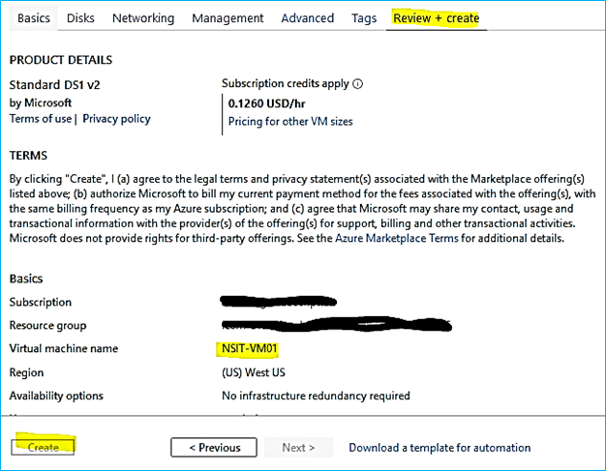

Similarly create NSIT-VM02

**5.8. Load balancer Final Status**

* Load Balance Front End IP

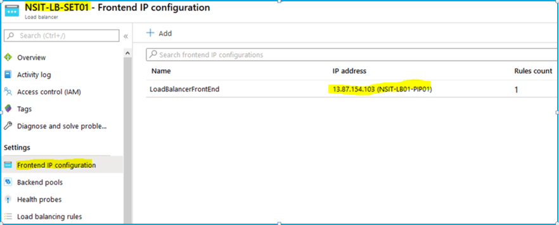

* Backend pools

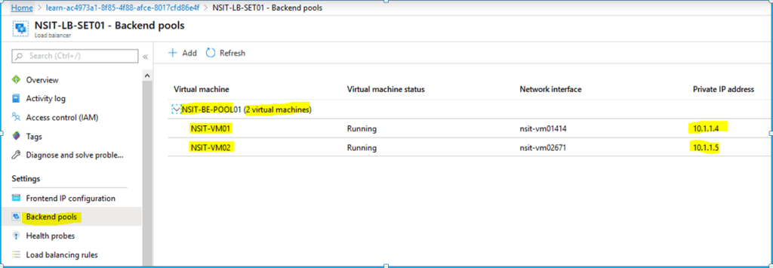

* Health probes

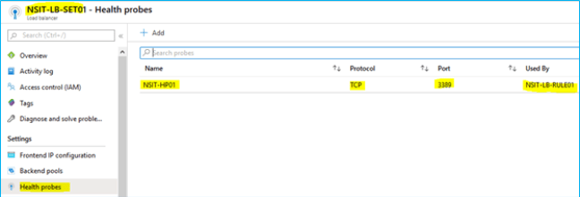

* Load balancing rules

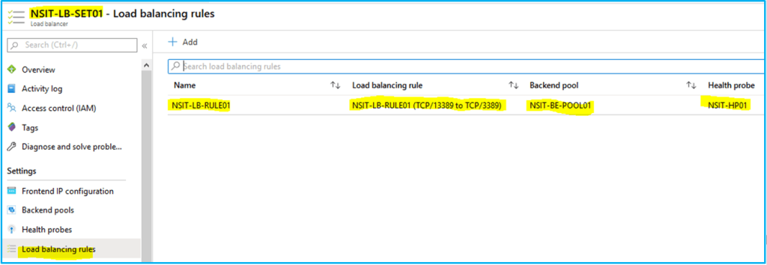

**5.9. Connect Load balancer**

* LB Public IP

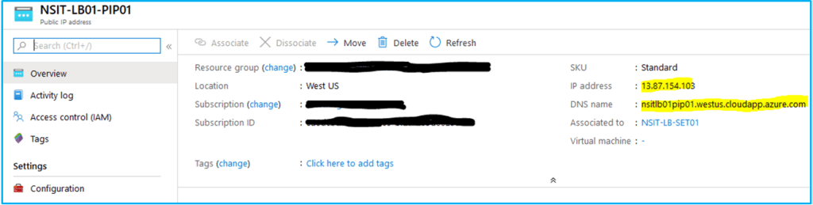

* RDP to Public IP “13.87.154.103” or public name “nsitlb01pip01.westus.cloudapp.azure.com” at port 13389

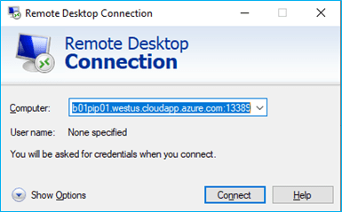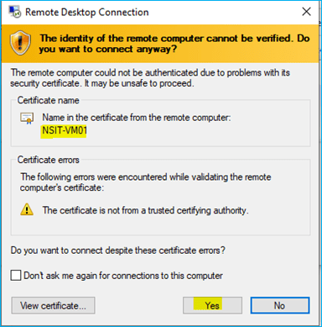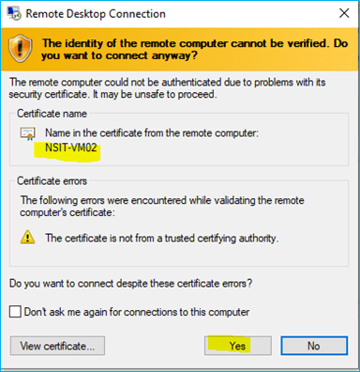

**5.10. Final result**

* RDP connected with same name nsitlb01pip01.westus.cloudapp.azure.com “13.87.154.103” to backend VM’s (NSIT-VM01 “10.1.1.4”) or NSIT-VM02 “10.1.1.5”).
* Port redirection 13389 <=> 3389

“nsitlb01pip01.westus.cloudapp.azure.com:13389” <=> NSIT-VM01:3389 or NSIT-VM02:3389

